INTRODUCTION

MODULE 3 FUNCTIONS

A function is a block of code that performs a specific task. A program can be broken into segments commonly known as functions, each of which can be written more or less independently of the others.
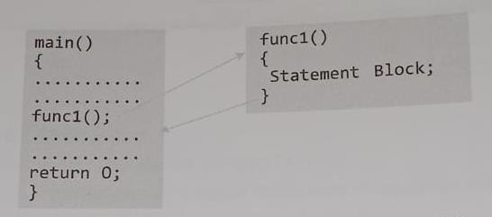

From the figure we can see that main() calls a function named func1(). Calling function is main() and called function is func1(). Once a compiler encounters a function call, the control jumps to the statements that are part of the called function. After the execution of called function, the control is returned back to the calling function.

Why are Functions needed?
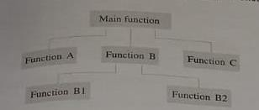
- Dividing a program into separate well-defined functions facilitates each function to be written and tested separately. The following figure shows that the main() function calls other function for diving the entire code into smaller sections. This is known as top- down approach.
- Understanding, coding and testing multiple separate functions is far easier than doing it for one big program.
- Without functions, main() functions would consist of countless lines of code.
- C provides pre-written and pre-tested functions which programmers can use which speeds up the development process.
- When a big program is broken into functions, different programmers working on that project can divide the workload by writing different functions.
- Like C libraries, programmers can also write their functions and use them at different points in the same program or different program.

Calling Function and Called Function: A function f that uses another function g is knows as calling function and g is known as called function.
Arguments/Parameters: The input that a function takes are known as arguments or parameters.
Function Declaration: It is declaration statement that identifies a function with its name, a list of arguments that it accepts, and the type of data it returns.
Function Definition: It consist of a function header that identifies the function, followed by the body of the function containing the executable code for that function
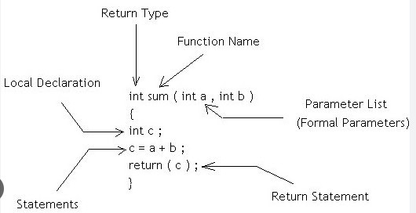

FUNCTION DECLARATION/FUNCTION PROTOTYPE
Before using a function, the compiler must know about the number of parameters and the type of parameters that the function expects to receive and the data type of the value that it will return to the calling function. Placing the function declaration statement before it use enables the compiler to check on the arguments used while calling that function.

General format for declaring the function is:
return_data_type function_name (data_Type variable1, data_type variable2,…..);
return_data_type specifies the data type of the value that will be returned to the calling function.
function_name is a valid name for the function.
data_Type variable1, data_type variable2… is a list of variable of specified data types that are passed from the calling function to the called function.
Example: float avg(int a, int b); This function calculates the average of two integer numbers a and b and return a floating point value.

FUNCTION DEFINITON
When a function is defined, space is allocated for that function in the memory. A function definition consists of 2 parts: Function Header and Function body

return_data_type function_name (data_Type variable1, data_type variable2,…..)
{
Statements
……. return(variable);
}

The number of arguments and order of arguments in the function header must be same as that given in the function declaration statement. First line is the function header and statements within {}is the function body which contains the code to perform a task. The list of the variables in the function header is known as formal parameter list. The parameter list may have zero or more number of parameters.
Example:
float avg(int a, int b)
{
float average; average=(a+b)/2; return(average);
}

FUNCTION CALL
The function call statement invokes the function. When a function is invoked the compiler jumps to the called function to execute the statements. Syntax of function call is as follows:
function_name(variable1, variable2, ….);
List of variables used in function call is knows as actual parameter list. When the function declaration is present before the function call, the compiler can check if the correct number and type of arguments are used in the function call.
Example: average=avg(10,20);

Program1: Write a program to add two integers using functions #include<stdio.h>
int sum(int a, int b); /* function declaration void main()
{
int a,b,c;
printf(“enter the values of a and b:”); scanf(“%d %d”,&a,&b); c=sum(a,b); /* function call printf(“sum=%d”,c);
getch();
}

int sum(int a, int b) /* function definition
{
int result’ result=a+b; return(result);
}

return STATEMENT
It terminates the execution of the called function and returns the control to the calling function. A return statement may or may not return a value to the calling function. Syntax is as follows:
return <expression>;

expression is optional, if present, it is converted to the type returned by the function. A function that has void as its return type cannot return any value to the calling function.
For the functions that has no return statement, the control automatically returns to the calling function after the last statement of the called function is executed.

A function may have more than one return statement. #include<stdio.h>
int check_relation(int a, int b); void main()
{
int a=3,b=5,res; res=check_relation(a,b); if(res==0)
printf(“EQUAL”); if(res==1)
printf(“ a is greater than b”); if(res==-1)
printf(“a is less than b”); getch();
return 0;
}
int check_relation(int a,int b);
{
if(a==b)
return 0; else if(a>b)
return 1;

else

}

return -1;

Output: a is less than b

PASSING PARAMETERS TO FUNCTIONS
When a function is called, the calling function may have to pass some values to the called function. There are 2 ways in which arguments or parameters can be passed to the called function. They are:
- Call by Value – values of variables are passed by the calling function to the called function.
- Call by Reference – address of variables are passed by the calling function to the called function.

CALL BY VALUE
In this method, the called function creates new variables to the store the value of the arguments passed to it. Therefore, the called function uses a copy of the actual arguments to perform the task. If the values are changed, then the change will be reflected only in the called function. No changes will be made to the variable of the calling function.
Example:
#include<stdio.h> void add(int n); void main()
{
int num=2;
printf(“value before calling function=%d”,num); add(num);
printf(“value after calling function=%d”,num);
}
void add(int n);
{ n=n+10;
printf(“value of num in called function=%d”,num);
}

Output:
Value before calling function=2 Value of num in called function=12 Value after calling function=2

Since the called function uses a copy of num, the value of num in the calling function remains same.

Example:
#include<stdio.h> void add(int n); void main()
{
int num=2;
printf(“value before calling function=%d”,num); num=add(num);

printf(“value after calling function=%d”,num);
}
void add(int n);
{ n=n+10;
printf(“value of num in called function=%d”,num); return n;
}

Output:
Value before calling function=2 Value of num in called function=12 Value after calling function=12
Here, the changed value is retuned to the calling function.

CALL BY REFERENCE
In call by reference technique, the function parameters are declared as references rather than normal variables. When this is done any changes made by the called function to the arguments it receives are visible in the calling function also.
To indicate the call by reference, an asterisk(*) is placed after the type in the parameter
list.

Example:
#include<stdio.h> void add(int *n); void main()
{
int num=2;
printf(“value before calling function=%d”,num); add(&num);
printf(“value after calling function=%d”,num);
}
void add(int *n);
{
*n=*n+10;
printf(“value of num in called function=%d”,num);
}

Output:
Value before calling function=2 Value of num in called function=12 Value after calling function=12

Advantages:
- Since arguments are not copied into new variables, it provides greater time and space efficiency.

- The called function can change the value of the argument and the change is reflected in the calling function.
- A return statement can return only one value. In case we need multiple return values, pass those arguments by reference.

SCOPE OF VARIABLES
In C, all constants and variables have a defined scope. Scope means accessibility and visibility of the variables at different points in the program. A variable or a constant in C has 4 types of scope:
- Block Scope
- Function Scope
- Program Scope
- File Scope

BLOCK SCOPE
If a variable is declared within a statement block then as soon as the control exits that block, the variable will cease to exist. Such a variable also known as a local variable is said to have a block scope. For example, if we declare an integer x inside a function, then that variable is unknown to the rest of the program.

#include<stdio.h> void main()
{
int x=10,i=0;
printf(“value of x outside the while loop is %d”,x); while(i<3)
{
int x=i;
printf(“\n value of x inside while loop is %d”,x); i++;
}
printf(“\n value of x outside the while loop is %d”,x);
}

Output:
value of x outside the while loop is 10 value of x inside while loop is 0
value of x inside while loop is 1 value of x inside while loop is 2
value of x outside the while loop is 10

FUNCTION SCOPE
Function scope indicates that a variable is active and visible from the beginning to the end of the function. Function scope is available with the goto label names. This means that the programmer cannot have the same label names inside a function

Example:
void main()
{
. .
..
loop: /* a goto lable has function scope */
.
.
.
goto loop;
.
.
}
In this example, the label loop is visible from the beginning to the end of the main() function. Therefore, there should not be more than one label having the same name with the main() function.

PROGRAM SCOPE
Variable declared within the function are called local variables. These are unknown to the other functions. If we want a function to access some variables which are not passed to it as arguments, then declare those variables outside any function blocks. Such a variables are commonly known as global variables and can be accessed from any point in the program.
Global variables are created at the beginning of the program execution and remains in existence through out the period of execution of the program. It is declared outside all the functions including main().

#include<stdio.h> int x=10;
void print(); void main()
{
printf(“value of x inside main() is %d”,x); int x=2;
printf(“\n value of local variable x in the main() is %d”,x); print();
}
void print()
{
printf(“ \n value of x in the print() function is %d”,x);
}

Output:
value of x inside main() is 10
value of local variable x in the main() is 2 value of x in the print() function is 10.

From the example we can see that local variable overwrite the value of global variables.

FILE SCOPE
When the global variable is accessible until the end of the file, the variable is said to have file scope. To allow a variable to have the file scope, declare that variable with the static keyword before specifying its data type:
static int x=10;
A global static variable can be used anywhere from the file in which it is declared but it not accessible by any other file. Such variable are useful when the programmer writes his own header file.

STORAGE CLASS
Storage Class defines the scope or visibility and life time of variables and functions declared within a C program. It also gives the following information about the variable or the function:
  - It determines the part of memory where storage space will be allocated for that variable or function.
  - It specifies how long the storage allocation will continue to exist for that function or variable
  - It specifies the scope of the variable or function.
  - It specifies whether the variable or function has internal, external or no linkage.
  - It specifies whether the variable will be automatically initialized to zero or to any intermediate value.

General Syntax: <storage_class_specifier> <data type> <variable name>

auto Storage Class

The auto storage class specifier is used to explicitly declare a variable with automatic storage. It is the default storage class for variables declared inside a block.
Example: auto int x;
It is deleted when the block in which x is declared is exited.
- All local variable declared within a function belong to automatic storage class by default.
- Scope of this variable is local to the block in which it is declared.
- These variables are stored in the primary memory of the computer.
- If auto variables are not initialized at the time of declaration, then they contain some garbage value.
Ex: #include<stdio.h> void func1()
{
int a=10; printf(“a=%d”,a);
}
void func2()
{

int a=20; printf(“a=%d”,a);
}
void main()
{
int a=30; func1();
func2(); printf(“a=%d”,a);
}
Output:
a=10 b=20 c=30

register Storage Class
When a variable is declared using register as its storage class, it is stored in a CPU register instead of RAM. The maximum size of the variable is equal to the register size. It is declared as follows:
register int x;

Register variables are used when quick access to the variable is needed. Each time a block is entered, the register variables defined in that block are accessible and the moment that block is exited, the variables become no longer accessible for use.

Example: #include<stdio.h> int exp(int a, int b); void main()
{
int a=3,b=5,res; res=exp(a,b);
printf(“%d to the power of %d=%d”,a,b,res);
}
int exp(int a, int b)
{
register int res=1; int i; for(i=1;i<=b;i++) res=res*a;
return res;
}

Output:
3 to the power of 5=243

extern Storage Class
The extern storage class is used to give a reference of a global variable that is visible to all the program files. Such global variables are declared like any other variable in one of the program files. To declare a variable x as extern write,
extern int x;
Memory is allocated for external variables when the program begins execution, and remains allocated until the program terminates. They have global scope i.e., these variables are visible and accessible from all the functions in the program.
Example:
//FILE1.c #include<stdio.h> #include<FILE2.C> int x;
void print(void); int main()
{ x=10;
printf(“\n x in FILE1=%d”,x); print();
return 0;
}

//FILE2.c #include<stdio.h> extern int x;
void print(void); void print()
{
printf(“\n x in FILE2=%d”,x);
}
main()
{
// statements
}
Output
x in FILE1=10 x in FILE2=10

static Storage Class
While auto is the default storage class for all local variables, static is the default storage class for all global variables. They have lifetime over the entire program.
static int x=10;

Static variables when defined within a function are initialized at the run time. When a static variable is not explicitly initialized by the programmer, then it is automatically initialized to zero when memory is allocated for it.
#include<stdio.h> void print(void); int main()
{
printf(“first call for print()\n”); print();
printf(“\n second call for print()”); print();
printf(“\n third call for print()”); print();
return 0;
}
void print()
{
static int x; int y=0;
printf(“Static integer variable x=%d”,x); printf(“\n integer variable y=%d”,y); x++;
y++;
}

Output:
first call for print()
Static integer variable x=0 integer variable y=0

second call for print() Static integer variable x=1 integer variable y=0

thirs call for print()
Static integer variable x=0

integer variable y=0
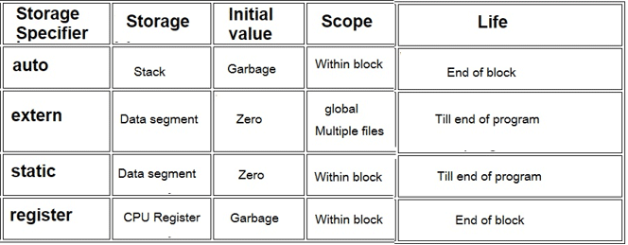

RECURSIVE FUNCTIONS

A recursive function is defined as a function that calls itself to solve a smaller version of its task until a final call is made which does not require a call to itself. Every recursive solution has two major cases:
- Base Case: Here, the problem is simple enough to be solved directly without making any further call to the same function
- Recursive Case: Here, first the problem is divided into smaller sub-parts, function call itself to obtain the solution for the sub-parts and the result is obtained by the combining the solution of simpler sub-parts.

Example 1: Factorial of a number
Factorial of n is the product of all positive descending integers. Factorial of n is denoted by n!. For example: 5! = 5*4*3*2*1 = 120
3! = 3*2*1 = 6
Base case is when n=1, the result is 1. i.e. 1!=1 Recursive case is factorian(n)=n*factorial(n-1)

5!
=5*4!
=5*4*3!
=5*4*3*2!
=5*4*3*2*1!
=5*4*3*2*1
Program: #include<stdio.h> int factorial(int n)
{
if (n == 0) return 1; else
return(n * factorial(n-1));

}

void main()
{
int number,fact; printf("Enter a number: "); scanf("%d", &number); fact = factorial(number);
printf("Factorial of %d is %d\n", number, fact); getch();
}

Example 2: Greatest Common Divisor
GCD (Greatest Common Divisor) of two numbers is the largest number that divides both of them. GCD can be found by using Euclid’s algorithm that states
GCD(a,b)= b if b divides a GCD(b,a mod b) otherwise

Working: a=62 b=8 GCD(62,8)
Rem= 62%8=6 GCD(8,6)
Rem= 8%6=2 GCD(6,2)
Rem= 6%2=0
Return 2

Program:
#include<stdio.h> int GCD(int, int); void main()
{
int n1,n2,res;
printf(“enter number 1 and 2”); scanf(“%d %d”,&n1,&n2); res=GCD(n1,n2):
printf(“GCD of %d and %d is %d”,n1,n2,res); getch();
}
int GCD(int x, int y)
{
int rem; rem=x%y;

if(rem==0) return y;
else
return (GCD(y,rem));
}

Example 3: FINDING EXPONENTS

EXP(x,y) = 1 y=0
X * EXP(x , y-1) otherwise

Working:
EXP(2,3)= 2 * EXP(2,2)
= 2 * 2* EXP(2,1)
= 2*2*2 *EXP(2,0)
= 2*2*2*1
= 8.

#include <stdio.h> int exp(int, int ); void main()
{
int num1,num2,res; printf("Enter two numbers: ");
scanf("%d, %d", &num1,&num2); res = exp(num1, num2);

printf(“Result = %d", res);
}

int exp(int x, int y)
{
if(y == 0)
return 1; else
return x * exp(x, y- 1);

}

Example 4: FIBONACCI SERIES
The Fibonacci series can be given as the following

0 1 1 2 3 5 8 13 21 ……..
Third number of the series is the sum of the first and second terms and go on. The general formula to do so can be given as follows.

FIB(n)=
- if n=0
- if n=1
FIB(n-1)+FIB(n-2) otherwise

#include<stdio.h> int fibonacci(int); void main()
{
int i,n,res;
printf("Enter the value of n: "); scanf("%d", &n);

for(i = 0; i< terms; i++)
{
res= fibonacci(n); printf("%d ",res);
}
}

int fibonacci(int n)
{
if(n == 0)
return 0; else if (n==1);
return 1;

else
{

}

return fibonacci(n-1) + fibonacci(n-2);

}

TYPES OF RECURSION
  - Direct Recursion: A function is said to be directly recursive if it explicitly calls itself. Here, Func() calls itself for all positive values of n, so it is said to be a directly recursive function.

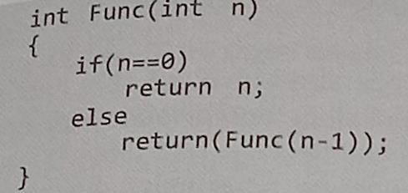

  - Indirect Recursion: A function is said to be indirectly recursive if it contains a call to another function which ultimately calls it. In the example, two function are indirectly recursive as they both call each other.
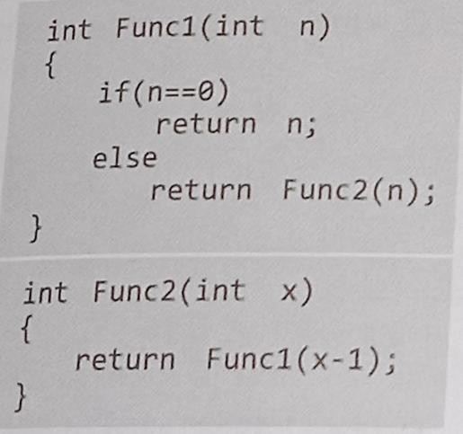

  - Tail Recursion: A recursive function is said to be tail recursive if no operations are pending to be performed when the recursive function returns to its caller. Tail recursive functions are highly desirable because they are much more efficient to use as the amount of information that has to be stored on the system stack is independent of the number of recursive calls. Below is an example of tail recursion
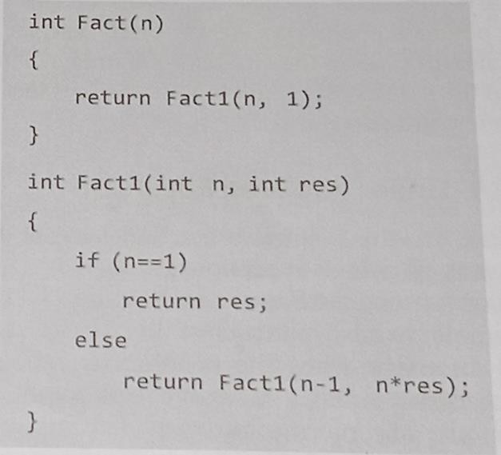

A non tail recursive function is the one that has a pending operation to be performed. Information about pending operation must be stored, so the amount of information directly depends on the number of calls. Below is an example of non tail recursion

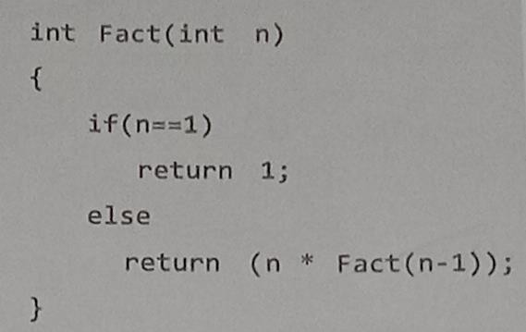

  - Linear and Tree Recursion: A recursive function is said to be linearly recursive when the pending operation (if any) does not make another recursive call to the function. The factorial function is a linearly recursive as the pending operation involves only multiplication to be performed and does not involve another recursive call.
A recursive function is said to be tree recursive if the pending operation makes another recursive call to the function. Fibonacci function is tree recursive because the pending operations recursively calls the fib function.

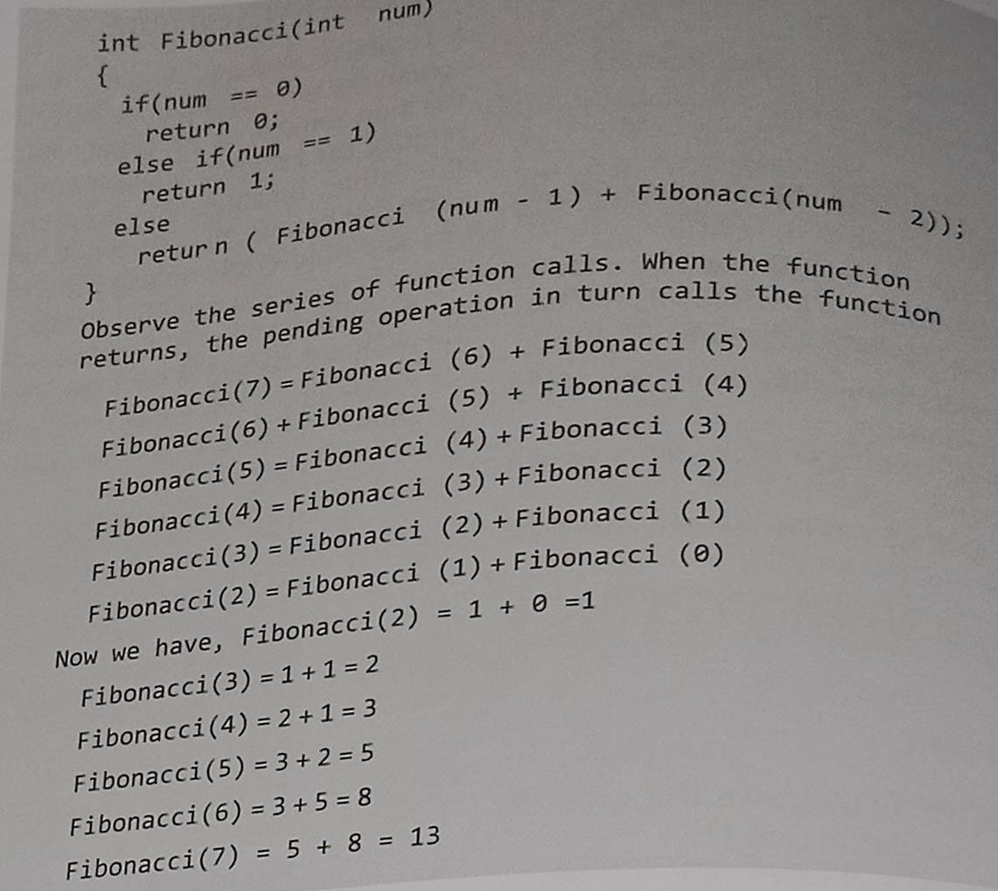

TOWER OF HONAI: The tower of Hanoi is one of the main applications of recursion. Consider three rings mounted on pole A. The problem is to move all these rings from pole A to pole C while maintaining the same order. Smaller disk must always come above the larger disk.
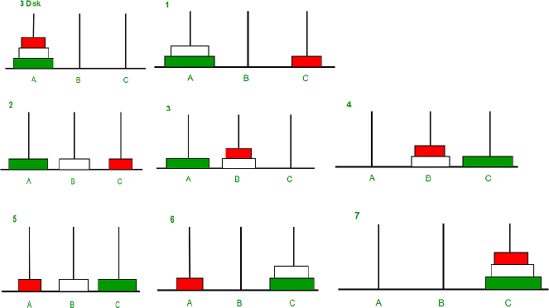

Base Case: if n=1 move the ring from A to c using B as spare Recursive Case:
    - Move n-1 rings from A to B using C as spare
    - Move the one ring left on A to C using B as spare
    - Move n-1 rings from B to C using A as spare
Program:
#include <stdio.h> #include <conio.h>
void hanoi(int,char,char,char); void main()
{
int num; clrscr();
printf("\nENTER NUMBER OF DISKS: ");
scanf("%d",&num);
printf("\nTOWER OF HANOI FOR %d NUMBER OF DISKS:\n", num);
hanoi(num,'A','B','C');

getch();
}
void hanoi(int n,char source, char dest ,char spare)
{
if(n==1)
printf("\nMOVE DISK FROM %c TO %c",from,other);

else
{

}
}

hanoi(n-1,source,dest,spare); hanoi(1,source,dest,spare); hanoi(n-1,spare,dest,source);

RECURSION VS ITERATION

